Derivation

Hwang Chan IL

c.hwang

5415279

1. **Elimination of clockwise oriented quadrilaterals**

By using cross product rule for every side of quad, we can define every vertex is oriented counter-clock wise. If any side of quad is negative, then the quad is not counter clock-wise oriented.

Here’s the three vertices on one quadrilateral.

)

)

And the vertices for cross product

)

)

By using right-hand rule, we can define the quadrilateral is clockwise oriented if the all result of cross product from vertices of quadrilaterals is negative.

Otherwise, the quadrilateral is counterclockwise.

1. **Elimination of concave polygons**

Calculate all Cos(α) on the polygon between 2 lines start from one point on polygon, by using dot product we can define polygon is whether convex or not.

If any Cos(a) is negative, then the quad is concave.

Let’s assume this three vertices are on square.

)

)

And the vertices for dot product

)

)

Because determinant of dot product that determine whether it is positive or not is only Cos(α), Cos(α) determine it is concave or not.

1. **Mapping**

We use triangle, most basic polygon, for texture mapping. We use the x and y value from the object that we want to do mapping, to get u and v. And since the u and v are the values for the continuous texel space, we need to change these values for discrete texel space. To do so, we use following formula:

Now we calculate , and then I use texture [. to get actual color data from memory.

1. **Texture Functions**
2. Wrapping : image is repeated : if U, V are higher than 1, it will be repeated.

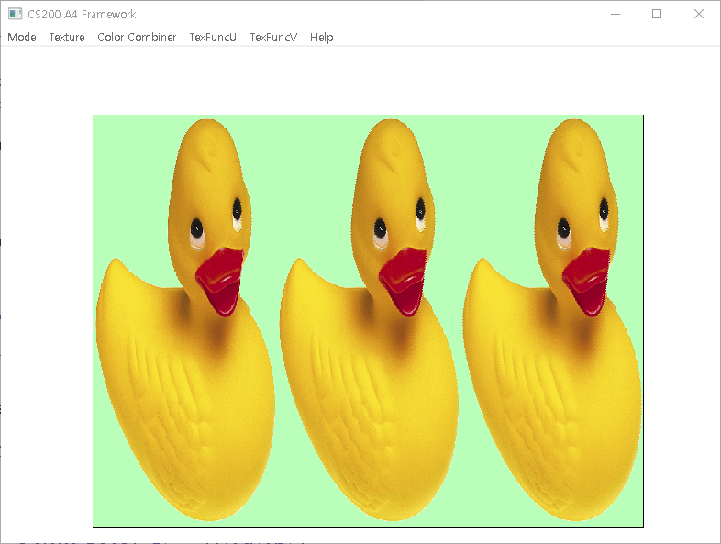

1. Mirroring : image is repeated, but it is flipped on every other repetition

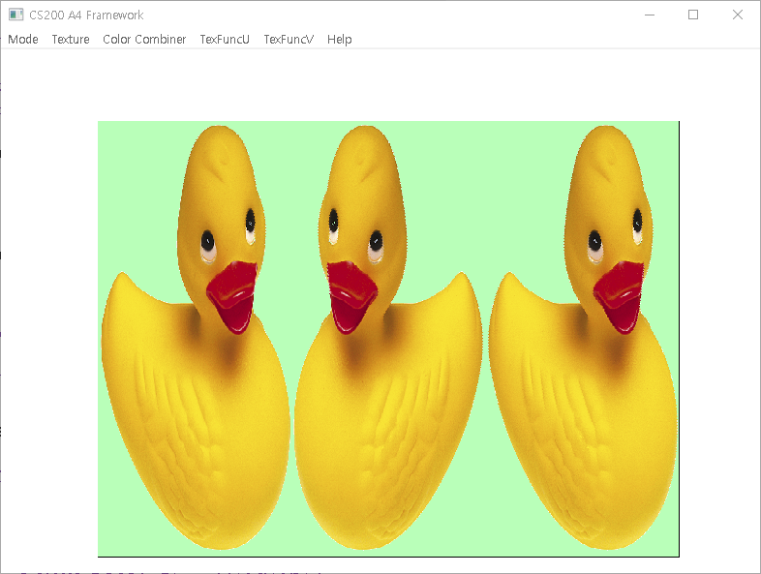

1. Clamping : the size of the image is adjusted

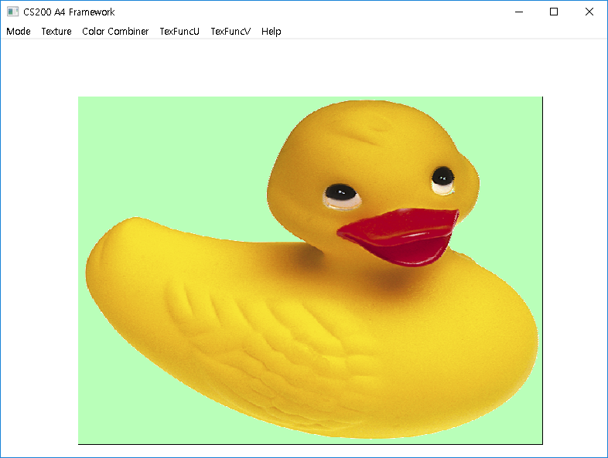

1. **Planar Interpolation**
2. Planar Interpolation:

1. Planar Interpolation:
2. Computation with &

These interpolations are added everytime x and y values change as in the case of linear interpolation.

1. **Color Combination**
2. Decal : Use the alpha value of the texture to blend between surface and texture color.

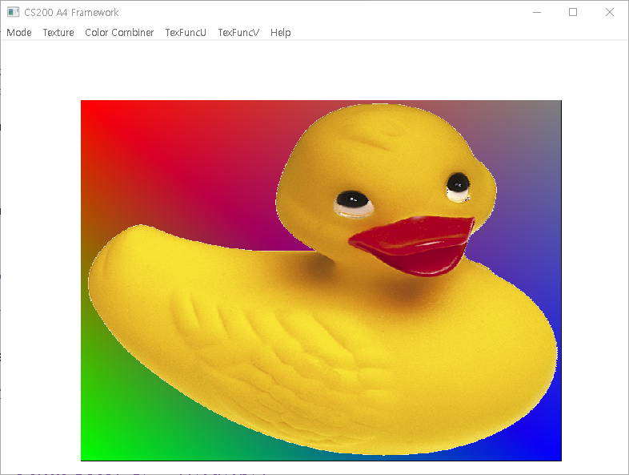

1. Modulate : surface color modulated by texture color to give surface shaded appearance.

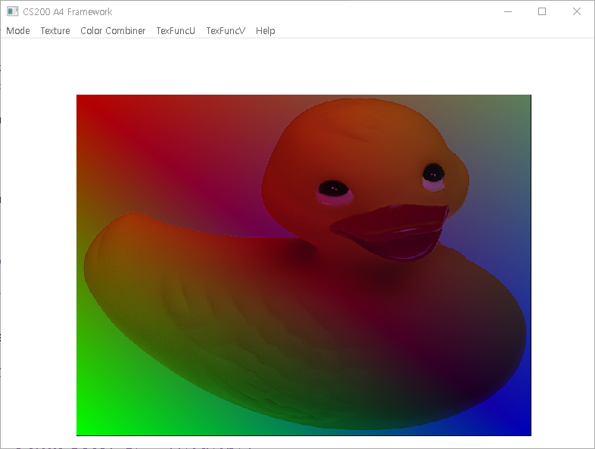

1. Replace : Just use texture color



1. Gourard : Just use surface color

